**KWAME NKRUMAH UNIVERSITY OF SCIENCE AND TECHNOLOGY**

**COLLEGE OF ENGINEERING**

**DEPARTMENT OF GEOMATIC ENGINEERING**

**SPECIFIC METRICS TO MEASURE THE VALUE OF GIS IN EMERGENCY FIRE RESPONSE IN THE GREATER ACCRA REGION OF GHANA**

A thesis submitted to the Department of Geomatic Engineering, College of Engineering, Kwame Nkrumah University of Science and Technology, Kumasi in partial fulfillment of the requirements for the award of the degree of Master of Philosophy in Geographic Information Systems.

**BY**

**ELISHA AKANLO ANANKANSA**

(Bsc. Geomatic Engineering)

**JANUARY, 2023**

# ABSTRACT

Timeous or instant response to fire outbreaks in Ghana like any country over the world is important for emergency response. The reason being that delay in the response or reaction of firefighting services can have dire repercussions. Death, injury, damage to properties and financial loses or cost are but a few of the adverse effect that may arise as a result of delay or lack of access by emergence services. Rapid urbanization in cities like Accra has been blamed as a contributory factor to the incidents of fire in the Region. This poses difficulty in developing and sustaining efficient emergency response procedures. Ensuring that all service areas are properly covered is a primary pre-occupation of city planners so that fires situations and its related consequence may be dealt with within appreciable response time or distance. This research therefore aimed to optimize the geographic distribution of existing fire service stations in the Greater Accra Region through spatial coverage and network analysis. For this purpose, the ArcGIS environment buffer together with network analysis tool was utilized to analyze the spatial coverage area of fire stations in the Greater Accra Region, based on internationally acceptable fire standard codes used by the National Fire Protection Association (NFPA). The research focused on identifying specific places in the study area that does not have fire response coverage or fall outside the reach of existing fire service stations. This study explored the multi-criteria analysis module using the weighted overlay in ArcMap to ascertain suitable sites for new fire stations in GAR in order to improve efficient and effectiveness of emergency response within the Region. Hence the research posits that in enhancing geographic distribution of fires stations in GAR, geospatial tools have proven to be efficient and useful.

# TABLE OF CONTENTS

DECLARATION 2

DEDICATION 3

ACKNOWLEDGEMENT 4

ABSTRACT 5

TABLE OF CONTENTS 6

LIST OF TABLES 8

LIST OF FIGURES 9

LIST OF ACRONYMS 10

CHAPTER ONE 11

INTRODUCTION 11

1.1 Background of Study 11

1.2 Problem Statement 13

1.3 Aim, Objectives and Research Questions 15

1.4 Research Rationale 16

1.5 Conceptual Framework 17

1.6 Research Design 19

1.7 Organization of Study 21

CHAPTER TWO 22

LITERATURE REVIEW AND CONCEPTUAL FRAMEWORK 22

2.1 Introduction 22

2.2 Emergency Response and Management 22

2.2.1 Emergency Management 22

2.2.2 Location and its Influence in emergency response 23

2.3 Parameters in Fire Response Management 24

2.4 Fire Incidents and Management in Ghana 26

2.4.1 Fire Incidents in Ghana 26

2.4.2 Emergency Management Operations of the Ghana National Fire Service (GNFS) 28

2.5 Geographic Information Systems (GIS) and Emergency Management and Response 29

2.5.1 Geographic Information Systems (GIS) in Emergency Management 29

2.5.2 Network Analysis for Determining Service Area Coverage 30

CHAPTER THREE 33

STUDY AREA AND RESEARCH METHODOLOGY 33

3.1 Introduction 33

3.2 Study Area 33

3.2.1 Location 33

3.2.2 Population Size/ Growth 33

3.2.3 Economic Characteristics 34

3.2.4 Fire Management in the Greater Accra Region. 35

3.3 Sources of Data 36

3.4 Methods 37

3.4.1 Research Design and Methodology 37

3.4.2 Spatial distribution of existing fire stations 38

3.4.3 Spatial Metrics for Analyzing Service Area Coverage 39

3.4.4 Predicting Suitable Areas for Fire Stations 40

3.5 Limitations of Study 41

CHAPTER FOUR 42

RESULTS AND DISCUSSIONS 42

4.1 Introduction 42

4.2 Results 42

4.2.1 Spatial Distribution of Fire Stations in the Greater Accra Region 42

4.2.2 Service Areas of Existing Fire Stations 43

4.2.3 Predicting Areas Suitable for Citing New Fire Stations 47

4.3 Discussions 48

CHAPTER FIVE 51

CONCLUSIONS AND RECOMMENDATIONS 51

5.1 Introduction 51

5.2 Conclusions 51

5.3 Recommendations 52

REFERENCES 53

# CHAPTER ONE

# INTRODUCTION

## 1.1 Background of Study

In developing countries, emergency response services (ERS) frequently face the difficulty of dispersing resources in a way that ensures optimal service. Furthermore, inadequate solutions are frequently the result of the exclusion of heterogeneous urban fabric and significant variations in travel time and coverage demand throughout the day (Nousiainen, 2021). Several studies have provided critical insights into the dynamic changes that occur throughout the day while designing the site and relocation strategy for Emergency Response Services (ERS) in a city.   
Degel et al., (2015) report variations in demand, journey time, and effective coverage during different hours of the day and different days of the week. A viable method that incorporates these differences is explained, as disregarding them could lead to erroneous estimations of time-dependent coverage, fleet size, and positions. It's more challenging to make an estimate because there are so many different kinds of firefighting vehicles (Berg et al., 2016). An efficient firefighting plan necessitates a firm understanding of the spatial and temporal patterns of fire occurrence, the function of the built environment, and the components of urban settlements and their interconnections (Turner et al., 2017). As a result of ignoring some of these factors in earlier research, fire response times were underestimated.

To put it simply, fire is an essential part of our daily lives. It's important to remember that fire is a powerful instrument that may easily backfire and cause great harm if not used properly in homes, workplaces, schools, and other public areas. Urban fires are becoming an increasingly serious problem in modern culture. Every year, thousands of lives are lost and millions of dollars are destroyed due to fires in Ghana. Almost every day, news breaks of a fire that has broken out somewhere in Ghana, sending the populace into a state of panic. Kejetia and Mokola Market, the two of the city's most important marketplaces, are classic instances of places that have experienced fires.

Fires continue to create significant economic losses for Ghana every year; in 2013, for example, almost 11,000 Ghanaians were directly impacted by fire and explosions, and the cost of such accidents was roughly $7 million (Tulashie et al., 2016; Simpson 2010). According to Anaglatey (2013), electrical issues due to improper wiring have been one of the primary causes of fire outbreak in Ghana. Population growth sometimes coincides with a rise in human activities that necessitate the use of fire, and unfortunately, this trend often leads to an increase in carelessness while dealing with fire.

Rapid urbanization in Ghana may be one factor contributing to the country's rising fire risk (Addai et al., 2016). This is due to the fact that the bulk of people who once lived in rural areas have relocated to metropolitan centers. Ghana is quickly urbanizing, as is typical for developing countries. The fast growth of urban populations has outstripped the capacity of most city governments to provide adequate services, leading to the proliferation of slums and other forms of informal settlement. Most of the residents of these areas are now vulnerable to a variety of hazards, fire being the most prominent of these threats.

The Ghana National Fire Service (GNFS) is responsible for preventing fires and other disasters from causing loss of life, property, and natural resources. The fire service needs to use cutting-edge equipment, strategies, and instructional practices to keep up with rising public expectations. The modern fire service has a number of issues that have increased the significance of risk management, readiness, and mitigation (ESRI, 2006). Without proper preparation and planning, timely and effective responses are impossible to achieve on a consistent basis. Geographic information system (GIS) technology is one of the new instruments assisting the fire department in improving the quality of emergency services it provides.

According to Shekhar et al. (2008), GIS supports planning, preparedness, mitigation, response and incident management. Safe transportation routes, location of resources and services, the extents and location of damaged areas are some of the essential information needed during fire outbreaks and have spatial components.

The fore mentioned essential information is useful in all phases of emergency management (Cutter 2003; Al-Khudhairy 2010). There are, however, challenges to overcome in the exploitation of spatial data and geographic information systems (GIS) in the case of emergency management (Zerger & Smith, 2003; Mansourian, 2005).

As a result, Geographical Information System (GIS) is a resource that advises the decision maker on potential locations for the project (Jankowski, 1995). Many factors have a role in determining where fire stations should be located; making this an issue that may be analyzed using spatial multi criteria decision analysis (SMCDA) (Nyimbili et al., 2018). Therefore, this research lays the groundwork for a unified GIS strategy by providing a network analysis-based method for selecting suitable locations for urban fire stations. Using GIS, you can find a location that meets your needs by comparing it to a set of criteria. This research, therefore aims to use geospatial technologies to investigate the current literature and analyze spatial data in order to find the best possible locations for fire service stations in the Greater Accra Region.

## 1.2 Problem Statement

In the event of a fire, fire stations are a vital aspect of emergency management services, providing a critical function in protection and response actions. As city populations grow, more fire departments will be needed to keep up with the growing dangers. As a result, strategic location planning for emergency services is crucial for meeting the needs of the populace and keeping people safe while also protecting vital infrastructure (Nyimbili et al., 2018).

Emergency planning has been stimulated by recent improvements in geo-technological areas in which an increasing amount of spatial data is required for complex decision-making by emergency responders (Erden, 2012). A quick and agile response, are two critical factors that determine the efficiency of operational response to emergency call-outs. Timely response is paramount to ensure the safety of people, and protection of properties and the physical environment (Challands, 2010).

Due to the rapid urbanization in most cities like Accra in the Greater Accra Region (GAR), there has been a high rise in the number of cars causing more pressure on the road networks, hence putting it in a dilapidating state in relation to the intense traffic situation; all these severely influence the accessibility of fire stations.

In view of that, out-moded approach for locating station sites by simulating fire outbreaks within districts are inadequate to accomplish criteria in these scenarios. Hence, it is deemed necessary to widen advanced research approaches, such as the use of GIS tools for optimizing location of fire stations.

When an emergency call is made, time is of the essence (Church and Murray, 2018). Expansion of a fire can often exceed its initial volume in a matter of minutes. The ability to quickly extinguish a fire and evacuate people inside is crucial for limiting damage (Walls et al., 2019). The extent of fire damage is proportional to the lag time that elapses between the time a fire is started and when it is put out (Walls et al., 2019). As with any medical emergency, time is of the essence in the delivery of emergency medical care. There are some medical emergencies where only prompt treatment by emergency medical professionals can ensure a patient's survival. Time is of essence when it comes to saving lives and preserving property during a fire or medical emergency (Fischer et al., 2019).

Providing field expert and decision makers with access to accurate and reliable up-to-date data for their exact task are a challenge. In view of that, policy makers and practitioners has adapted spatial analytics some times to capture spatial coverage and accessibility to locations (Kiran et al., 2020). Hecht et al. (2019_ and Kiran et al. (2020), identified other studies which considered several factors such as cost, time, population/dwelling density, socioeconomic conditions and political interest in conjunction with location models to assess the capability and competency of emergency response. Yet, quite a few studies have highlighted on projection of future population growth to notify location decision choices for new fire stations in areas which are likely to cause greater future hassles for emergency service (Donner et al., 2008).

Fire departments in Ghana continue to face difficulties responding quickly to calls for help, especially in the context of the country’s rapidly expanding metropolitan centers, which are witnessing both rapid population expansion and considerable changes in their urban shape. Timely response can be maintained with little resources by strategically placing fire stations in accordance with the shifting demand for services. Thus, a primary objective for fire agencies is to pinpoint optimal sites for setting up fire stations in order to create a fire network that provides uniform coverage.

## 1.3 Aim, Objectives and Research Questions

The main aim of this research is to elaborate on certain metrics or parameters that need to be considered when dealing with emergency fire response. To tackle the highlighted core objective the sub-objectives and research questions in Table 1.1 have been formulated.

***Table 1.1: Research objectives and questions***

|  |  |
| --- | --- |
| **Research objectives** | **Research Questions** |
| 1. To identify the existing fire response systems in Greater Accra Region (GAR) | 1. What are the existing fire response systems in Greater Accra Region (GAR)? |
| 1. To identify the spatial metrics covered by existing fire systems in the study area. | 1. How can the spatial metrics be identified with the use of GIS? |
| 1. To predict suitable sites for new fire systems for efficiency. | 1. How can these metrics be used to predict new emergency response systems? |

## 1.4 Research Rationale

In a life-or-death crisis, having accurate knowledge about all factors is crucial. Population estimates, weather predictions, sensor readings, transit options, the presence of beneficial agents, land use and cover values, and so on are all examples of this type of data. In addition, the emergency management process is dynamic since it entails a number of distinct processes, all of which are spelled out in standard operating procedures that allow first responders like paramedics, firefighters, and police to reach the scene of an incident as quickly as possible to minimize the loss of life and property. However, there is a dearth of literature in Ghana addressing emergency response. This study aims to address this knowledge gap by providing an in-depth discussion of the measurements and factors that should be taken into account when responding to emergency fires in Ghana using geospatial technology.

The results of this study also have substantial consequences for public policy. The challenges created by rapid urbanization and the imperative for more effective resource management has elevated the significance of Emergency Service System strategic planning. Fire stations in GAR are concentrated in the city center, but the shifting urban landscape and population dispersal necessitate the closure or relocation of some of these facilities to ensure enough response time in the event of a fire. Therefore, the results of the empirical study can give local officials a blueprint for how to best distribute fire and rescue services across their communities. Among other factors relevant to citing fire stations, prioritizing accessibility and service coverage can help achieve this goal.

## 1.5 Conceptual Framework

Effective decision-making informed by GIS concepts was crucial to achieving the aims of this research. One method used to aid decision makers in weighing numerous elements is called "spatial decision analysis." In order to reach the most beneficial conclusion, it is necessary to apply a rational analysis and comparison of multiple criteria, many of which are at odds with one another. The use of GIS has a major impact on efficient management because most problems in the urban environment have a spatial component.

When it comes to urban space problems, there are usually a plethora of solutions available for a solution. The use of a Geographic Information System (GIS) is a method that transforms and integrates geographical data and value judgments to deal with location suitability difficulties. This is achieved through thinking about geographical data models, the spatial dimension of the evaluation criteria, and potential solutions. As a result, Figure 1.1 represents the study's conceptual framework model.

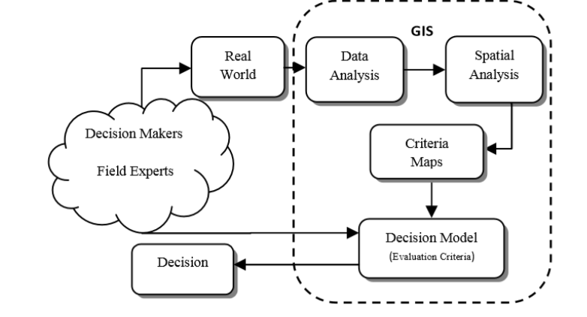

**Figure 1.1: Conceptual Framework underlying the study (**source: Siobhan & Ellis (2019).)

Based on Figure 1.1, Siobhan and Ellis (2019) argue that GIS-MCDA is preferable to more simplistic methods like binary or "coincidence" analysis since it relies on more rigorous criteria. Decision makers are assumed to take a static stance in the model. Figure 1.1 depicts the conceptual framework for identifying the key stakeholders who determine the optimal spatial distribution of amenities within a given region of interest. Geospatial technologies enable the transformation of data from real-world contexts, such as population density, elevation, and accessibility, into formats suitable for data and geographic analysis. Assigning weights to the various criteria in facility siting allows for the creation of criteria maps. Decision modeling can make use of the criterion maps to assist in making well-informed decisions about site selection.

Figure 1.1 therefore summarizes the benefits of GIS for decision-makers by showing how it may be used to manage several criterion and spatial data values simultaneously. Incorporating statistical models like AHP and FAHP into a GIS-MCDA further improves the analysis's credibility and applicability. While Figure 1.1 is a model, it has been assumed that GIS tools can be used to generate criterion maps that will aid in the decision-making process of field specialists when it comes to citing fire stations in the Greater Accra Region.

## 1.6 Research Design

The research was conducted to follow a scientific methodology. In this contexts the research approach has been developed to enable the research question to be answered in a feedback loop.

The research design comprises of 4 activities which are in phases, i.e phases 1 to phase 4. The phases has been structured in relation to the chapters.

The research design is organised as depicted in Figure 1.2

Chapter 2

Chapter 1

Introduction

* Background study
* Identification of problem
* Development of research questions

Chapter 5 – Conclusions and Recommendations

Chapter 4 – Results and Discussions

Chapter 3 – Study Area and Research Methodology

Chapter 2 – Review of literature on prior works

Conclusions and Recommendations

* Summary of research and future works

Chapter 1 - Introduction

Chapter 5

Phase 4

Phase 1

Phase 2

Phase 3

Identification of metrics

* Service coverage
* prediction

Literature Review

* Analysis on prior works

Conceptual Framework

* Using GIS in decision making

Chapter 3 & Chapter 4

Validation & Discussions

Objective 3

Prediction of new site location

Objective 2

Objective 1

Analysis of Data

* Spatial distribution
* Identification of metrics

Data gathering

* Secondary data

**Figure 1.2: Research design of the study**

## 1.7 Organization of Study

The study is organized into five (5) main sections. Chapter One (1) highlights on a general introduction to the study through the background, problem statement, research objectives and the rationale behind the study. Chapter Two (2) reviews the key concepts to provide the theoretical framework to support the objectives stated in the study. Chapter Three (3) focuses on the methods employed in collecting and analyzing the empirical data used for the study. It presents the limitation in the research. Chapter Four (4) presents the results from the empirical study and discuss them against literature. Chapter Five (5) summarizes the research and gives insightful recommendations in effective emergency management policies within the Region.

# CHAPTER TWO

# LITERATURE REVIEW AND CONCEPTUAL FRAMEWORK

## 2.1 Introduction

In order to comprehend how geospatial technology may be utilized to expound on specific metrics or factors that need to be taken into account while dealing with emergency fire response, this section delves into significant literary works. Investigation is also conducted on a critical issue relating to the study of emergency management. The importance of proper location is emphasized, as well as the actions of the Ghana National Fire Service (GNFS). There are also references to a number of academic studies and media articles about fire incidents in Ghana. This section covers both the network analysis tool and the placement of GIS tools for best results. In this section, the study's foundational idea is also stated.

## 2.2 Emergency Response and Management

### 2.2.1 Emergency Management

Procedures put in place to assists limit risk and preserve lives in the event of a disaster can be summed up as emergency management (Waugh et al., 2007). Building more secure, resilient communities that can handle emergencies is the fundamental tenet of emergency management. In order to develop, maintain, and improve the community's ability to prevent, prepare for, respond to, and recover from natural disasters, terrorist attacks, or other man-made disasters like fire outbreaks, emergency management organizes and coordinates these procedures (Moe et al., 2006).

Also, GIS and emergency management revolve around planning, analysis and action. These areas can be improved by spatial analysis, which seeks to analyze patterns of human behavior in a particular location (Osaragi et al., 2017). When used correctly, spatial analysis can help emergency responders act and prevent fatalities, injuries and damage in order to help communities return to normalcy as quickly and safely as possible. Every efficient emergency response system is based on the idea that by acting quickly, the loss of life and property can be minimized.

Time is therefore a key component in the creation of emergency response management systems, particularly in the event of a fire outbreak (Forkuo & Ballard, 2013). The likelihood that more lives and property are at risk increases the longer it takes to respond to a fire disaster. As a result, the amount of property destruction is directly related to the amount of time between a fire outbreak and a response to firefighting (Osaragi et al., 2017). This means that substantial resources need to be invested in selecting ideal sites, defining acceptable facility capacity standards, and building emergency management capabilities (Geng et al., 2020).

### 2.2.2 Location and its Influence in emergency response

In recent years, there has been an uptick in the number of scholarly works dedicated to the topic of location selection (Mara et al., 2021; en et al., 2011), despite location science's lengthy pedigree. The field of location science has been broken down into specialized areas thanks to the findings of numerous academic studies, one of which is the identification of nearby hospitals and other emergency services. Police, firefighters, and other emergency personnel all work to ensure the public's safety and have the same overarching objective: to respond quickly to calls for help so as to minimize casualties (McEntire, 2015). The placement of fire stations is planned to ensure that all residences receive the same level of service, regardless of location or risk, and at the same time (Kahanji et al., 2017). Therefore, the efficiency of emergency response during fires is greatly influenced by the number and location of fire stations (Lui et al., 2006).

Research on fire incidents in Accra (Appiah, Damnyag, Blay, & Pappinen (2010); Forkuo & Quaye-Ballard, 2013; Norman, Awiah, Aikins, & Binka, 2015) suggests that poor road networks, a lack of maintenance, and unchecked human and vehicle traffic have all contributed to the Ghana National Fire Service's inability to respond rapidly to fires. In the event of a fire, these risks frequently lead to the annual loss of substantial amounts of capital resources. When these conditions exist, they tend to slow down the response time of the Ghana National Fire Service. It's because of this that the service is thought to be incompetent to do its job. It is therefore essential that fire stations be strategically placed; in the event of an emergency, the fire department should be able to reach its destination within five minutes (Şen et al., 2011).

## 2.3 Parameters in Fire Response Management

Injuries, deaths, economic damage, and pollution are only some of the common outcomes of fires, which also pose a threat to the natural and built environments. Fires claimed the lives of 18,454 people in 31 countries in 2015, according to the International Association of Fire and Rescue Services (Brushlinsky et al., 2019).

Fires claimed the lives of 18,454 people in 31 countries in 2015, according to the International Association of Fire and Rescue Services (Brushlinsky et al., 2019). When it comes to protecting citizens, infrastructure, and natural resources from disasters like fires, fire and rescue services are among the most fundamental functions of government. Distributing funds for fire prevention and protection effectively is crucial to ensuring the safety of a community (Yao et al., 2019). The location of fire stations, the location of fire hydrants, the location of a water source, the road network for the best response, service area coverage, and time limits in responding to fire events scenes are all factors taken into account in fire response management (Yao et al., 2019). The geographical arrangement of fire stations is a major consideration in this regard, as it is crucial for rapid response to emergencies.

Fire station placement is a complex issue that takes into account several factors, including building cost, population density, water supply, risk of fire, and the preferences of decision-makers (Chevalier et al., 2012). The accessibility and service area of fire stations are of particular significance to this research. A fire station's service area is typically defined in terms of the maximum allowable distance or travel time from the station to an event, while accessibility refers to how quickly help can be dispatched in the event of an emergency. The degree to which injury and loss can be mitigated is influenced by both indicators, which are of fundamental interest to emergency services like fire rescue and emergency medical services (EMS). There has been extensive study into fire station site concerns using spatial optimization approaches that combine GIS and mathematical models due to the spatial character of access and service coverage (Chevalier et al., 2012; Yao et al., 2019).

Furthermore, the demarcation of service regions is one of the most critical challenges in spatial partitioning, as doing so fairly always increases the efficiency with which facilities are serviced (Murray, 2015). It has been the subject of substantial study in a number of fields, such as commercial zone planning, healthcare facility layout, and police patrol zone design. Building a spatial proximity model independent of coordinate geometry is challenging, despite the existence of numerous solutions for addressing the challenges of geographical partitioning and delimiting service areas. There has been a lot of work done on urban service planning in the past, but in today's complex world, striking a good balance between service demand and supply is still a problem. Due to growing urbanization and an uneven built environment, service demand varies widely between regions (Chevalier et al., 2012; Yao et al., 2019). Meanwhile, urban emergency services have been severely hampered by the proliferation of confusing roadways.

An urban fire station's primary mission is to respond rapidly to fires and other emergencies in its service area (Murray, 2015). However, the actual route of rescue vehicles is often overlooked in studies of current fire station service zones, despite the fact that it might take up a considerable amount of rescue time. In the context of fire rescue, fire trucks travel via a street network to reach incident sites, and in real-world applications, planners focus primarily on the partitioning of network segments to comprehend the availability of fire emergency service (Chevalier et al., 2012; Yao et al., 2019). As a result, it may be preferable to designate fire stations' coverage zones within the bounds of the existing roadway network.

Thus, the location set covering problem and the maximal coverage location problem (Chen et al., 2018) are two of the most prevalent and traditional optimization techniques used when deciding where to place fire stations. The optimal placements of fire stations can be determined by weighing many competing criteria such as transit time, distance, coverage, and cost (Yao et al., 2019). Fire station location decisions are now being made with the help of GIS, thanks to the development of cutting-edge technology.

## 2.4 Fire Incidents and Management in Ghana

### 2.4.1 Fire Incidents in Ghana

One of the most widespread issues in both developed and developing countries’, including Ghana, is fire accidents in urban environments (Addai et al., 2016). It is an unfortunate fact of Ghanaian history that every year, many lives and buildings are destroyed in fires (Addai et al., 2016; Anaglatey, 2013, Boateng, 2013). In 1983, for instance, a devastating fire swept through Ghana, leading to a food crisis that has since become a watershed moment in the country's history (Okyere, 2010). Anaglatey (2013) claims that traffic congestion makes it more difficult to respond to fires in urban areas because houses block off emergency exits and hide fire hydrants. The dynamics of fire occurrences in the urban sphere need a speedy reaction by fire and rescue services, independent of fire protection measures put in place by fire regulating agencies, as noted by Drysdale (2011). Most of these incidents happen at petrol stations, marketplaces, institutional buildings, and highly populated areas, making it difficult for the fire tender driver and crew to get to the scene quickly due to the heavy foot traffic (Addai et al, 2016; Fleming, 2009; Norman et al, 2015).

The availability and design of urban public service infrastructure have been challenged in several ways by Greater Accra's fast urbanization (Korah, 2021).Since urban surroundings within megacities exhibit widely varied patterns of dispersion, the potential for fire is also highly variable. A look at the numbers shows how frequently fires have occurred in the country is seen below.

**Table 2.1: Fire Incident Statistics in Ghana from 2019-2020**

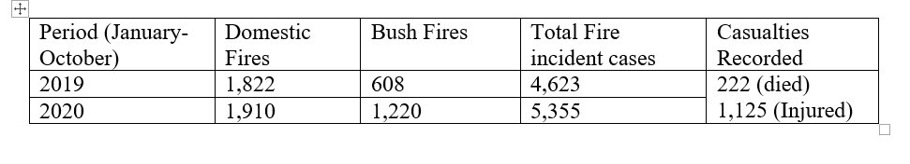(Source: Safo J.A, Daily Graphic Online (2021))

It is clear from looking at Table 2.1 that the number of fires occurring in Ghana has increased between 2019 and 2020. Fires started in homes accounted for 39.63% and 35.67% of all fires reported between January and October of 2019 and 2020, respectively. The Ghana National Fire Service (GNFS) classified the various types of fires into seven different groups: residential, commercial, electrical, electrical, vehicle, institutional, and bushfires (GNFS, 2021). Divisional Officer II Ellis Robinson Okoe, the GNFS's Public Relations Officer (PRO), told the Daily Graphic that people are ignoring fire safety regulations as the cause of the recent increase in fire incidents. He also attributed uptick in house fires at that time period on the lockdown. He claims that the epidemic caused over 272 house fires as a direct result of people being quarantined at home (Safo, 2021).

Also, more than 662 fires broke out in the Greater Accra Region in 2020. (GNFS, 2021) Mr. Okoe also emphasized the need of people knowing the locations of fire stations in their areas in case of an emergency. This is a great concept in theory, but it can't be implemented in practice because of the inadequacy of existing fire stations in the urban sphere.

### 2.4.2 Emergency Management Operations of the Ghana National Fire Service (GNFS)

The Ministry of the Interior in Ghana is responsible for a number of different agencies, including the Ghana National Fire Service (GNFS). The Ghana National Fire Service (GNFS) was founded in 1963 to control fires across the country. The GNFS is also responsible for public education campaigns about fire prevention and the construction of fire stations in major urban centers (Anni, 2018). The Ghana National Fire Service Act, 1997, Act 537, reinstated the Service in 1997. Preventing and controlling fires that are not wanted is the primary mission of the Service. The Ghana National Fire Service is tasked with ensuring the safety of people and property in all of the country's schools, marketplaces, MMDAs, and lorry parks, among other places, in accordance with the strategic goals set forth by the mother ministry. Additionally, Fire Management, Rescue, and Extrication are the Service's primary responsibilities.

By maintaining and improving public safety from fires and related emergencies, GNFS protects people, the environment, and the economy through a dedicated personnel and sufficient resources in accordance with the statutory requirements (GNFS, 2017). It is expected that the fire department will respond swiftly to fires in residences, businesses, public spaces, and retail establishments, however this has not been the case. The GNFS has been under constant media attack "for their failure to act rapidly and bring flames under control" whenever there has been a fire outbreak, despite the fact that the vast bulk of its resources are dedicated to fire response operations (Norman et al, 2015). (Gakpe & Mahama, 2014).

Inadequate funding for fighting and mitigating fire events may be at the root of the GNFS's incapacity to effectively respond to emergencies. The country has almost 25 million people in it in 2010, but only 45 fire trucks, not many individuals with fire-resistant clothes or breathing apparatuses, and no hydraulic platform to fight fires from (Gakpe & Mahama, 2014). In the case of a fire outbreak, the aforementioned factors make it challenging for the GNFS to implement efficient emergency management.

## 2.5 Geographic Information Systems (GIS) and Emergency Management and Response

### 2.5.1 Geographic Information Systems (GIS) in Emergency Management

GIS is a powerful tool for gathering, visualizing, and analyzing information for the purpose of making informed decisions (Drobne et al., 2009). Geographic information systems (GIS) allow for the storage, editing, manipulation, and analysis of geographically related data in order to produce interpretive maps useful in making decisions (Barnett et al., 1993). As a result, spatial analysis has found several applications in fields as varied as land suitability, urban planning, natural risk management, water resources management, and many more (Malmir et al., 2016). Due to the strength of its dynamic representation technology and analytical approaches, spatial analysis has played a significant role in the aforementioned fields.

In addition, there is substantial literature on the use of GIS technologies for fire station location selection and spatial optimization. Hogg (1968) found that the optimal number of fire stations and their most effective locations are critical in fire system analysis for minimizing losses, while Marsh (1999) discovered that the most important criterion of fire station location should be the minimum emergency response time. This part formed the foundation of a fire station site selection model developed by Plane and Hendrick (1977), who utilized reaction time as the coverage criterion to apply location set covering problem (LSCP) theory to the issue of site selection.

Also, Erden et al. (2010) and Chaudhary et al. (2016) used GIS and the Analytic Hierarchy Process (AHP) to conduct site selection and optimization assessments in a number of different regions and cities. Fire station site selection using the Maximal Coverage Location Problem (MCLP) model has also been done by Murray (2013) and Chevalier et al., (2012). Both fuzzy multi-objective programming (Yang et al., 2007) and a genetic algorithm (Badri et al., 1998) were used to locate fire stations, with the former taking into account travel time and distance while the latter considered cost, policies, and other factors. Multiple international studies have confirmed the usefulness of using GIS-based suitability models for site selection and facility allocation in the urban planning process.

Emergency responders can get a more complete picture of the situation thanks to the data layers and visuals provided by GIS in the event of an emergency (Abdalla, 2016). In essence, GIS serves as the foundation around which rescue maps can be built. Maps are incredibly helpful since they can illustrate, at a glance, the location of problems and the potential populations and areas that are impacted by them. In addition, new technologies like GPS, Lidar, and others with real-time sensors that record spatial data for spatial analysis have contributed to a rise in the availability of geospatial data in recent years.

### 2.5.2 Network Analysis for Determining Service Area Coverage

Network analysis' importance in GIS originates from its inclusion in the first data models, its wide range of practical applications, and its promising future prospects (Keenan et al., 2019). As a form of basic spatial representation, network analysis is capable of accurately depicting a wide variety of interactions. As a system of connected components, including lines (edges) and points (junctions), the network analysis tool enables the solution of network problems including finding the most efficient path across a metropolis, pinpointing the closest emergency vehicle or facility, defining a service area around a location, and deciding where to place citations (Evans & Minieka, 2017). The most popular is the ArcGIS Network Analyst add-on, which helps users resolve common network problems like finding the most efficient path across a city, pinpointing the closest emergency vehicle or facility, classifying the service area surrounding a given location, and deciding which facilities to keep open and which to shut down (ESRI, 2021).

Using the network analysis instrument helps determine accessibility in terms of journey time and distance. The network analysis software can also create a network coverage map. All roads that are below some arbitrary vulnerability threshold are included in this zone (ESRI, 2021). For instance, a fire department's 8-minute service area includes all roadways within that department's response time. An application of Dijkstra's algorithm is used in Network Service Analysis (ESRI, 2021). The coverage zone is determined by selecting a subset of edge connections within a given travel distance or time constraint. In order to produce route spaces, the edges are fed into a triangulated irregular network (TIN) database. Hence, internal TIN site heights are determined by the network distance along the lines. A much higher altitude is allocated to areas that are not passed through by the service area's coverage. In this TIN, areas between the given break values are extracted by employing an area-generation technique.

Many studies have been done throughout the world that employ GIS-based suitability models for site selection and facility allocation in the modern planning process (Gbanie et al., 2013). In citing emergency services such as fire stations, response time analysis may be conducted by combining a fire stations and street shapefiles (Rodriguez et al., 2020). Street data layer is represented in GIS as a sequence of intersecting lines on a map, resulting in a GIS street network (Rodriguez et al., 2020). Each segment of street line between junctions comprises attribute information such as road type, distance, and travel speed (miles or kilometers per hour) (Boeing, 2017).

In Ghana this information can be accessed freely by using Open Street Map provided by ESRI. Although buffer analysis can be used to determine accessibility, it does not take into consideration the means of travel from a point of interest. This limitation in buffer analysis is rectified by the network analysis tool by identifying accessible road network from the point of interest to surrounding areas. Thus, by combining road network data with the locations of fire stations and trip time, network analysis can be performed in a specified study area.

# CHAPTER THREE

# STUDY AREA AND RESEARCH METHODOLOGY

## 3.1 Introduction

This chapter is divided into two sections. The first section investigates the features of the study region taking into account the geography, demographic and economic factors of the ROI. The approach used in the study is discussed in the second section. Data, methods for collecting and analyzing the data, and the application of multi-criteria evaluation tools all fall under this category.

## 3.2 Study Area

### 3.2.1 Location

Figure 3.1 shows the location of the study area. The Greater Accra Region, the study area, which comprises 3,245 square kilometers of land, is the smallest area of Ghana's 16 administrative regions. The Greater Accra Region is bounded on the north by the Eastern Region, on the east by the Volta Region, on the south by the Gulf of Guinea, and on the west by the Central Region. This represents 1.4% of Ghana's total land area (GSS, 2018).

### 3.2.2 Population Size/ Growth

With a population of 5,455,692 in 2021, it is the most populous region before the Ashanti Region and makes up 17.7% of Ghana's overall population (GSS, 2021). With 87.4% of its population residing in urban areas, the Greater Accra region is the most urbanized in the nation (Songsore, 2020).

Accra, which is also the nation's capital of Ghana, serves as the Greater Accra Region's capital. It has a productive population of between 3.0 and 3.4 million and an estimated population of around 2 million (GSS, 2018). Only around 10% of Accra's population lives in its peri-urban districts, despite the city's population growth rate of about 3.4 percent annually (GSS, 2018). According to Duedall & Maul (2005), this number is anticipated to rise by 82 percent in 2025. Accra continues to draw an average of roughly 25,000 migrants annually due to the availability of economic opportunities (Appeaning Addo, 2010).

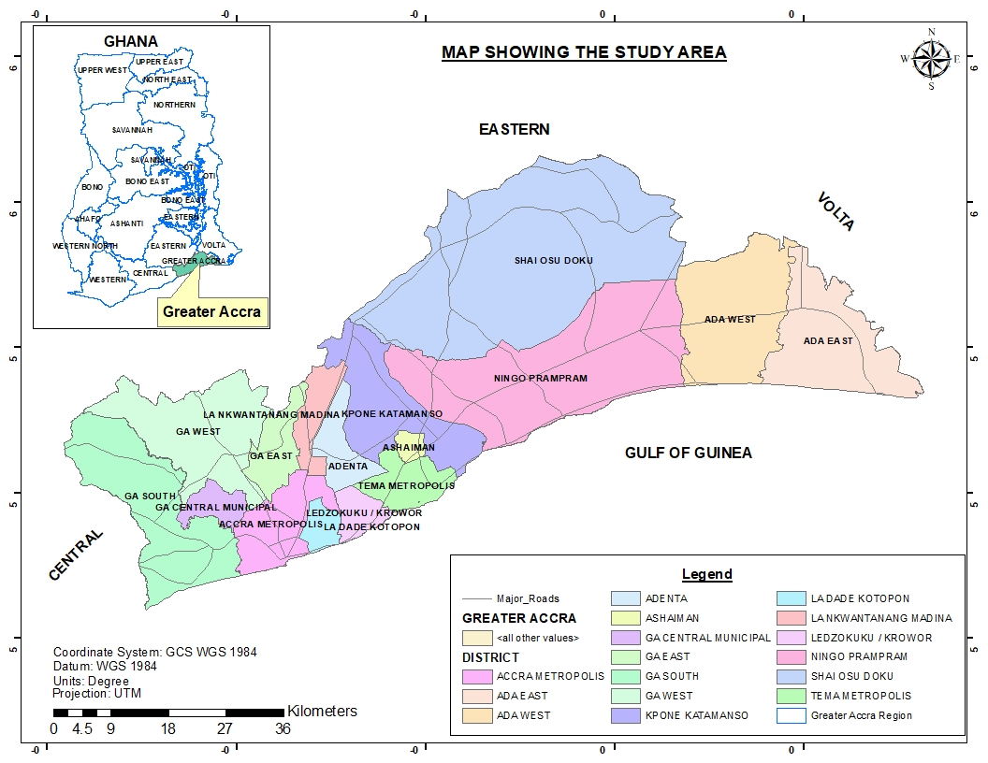

**Figure 3.1: Map of study area**

### 3.2.3 Economic Characteristics

Greater Accra Region is the political and commercial center of Ghana. It also serves as a hub for the transportation industry, as well as the production and distribution of goods, as well as the banking, insurance, and telecommunications industries. Accra's expanding global influence and connectivity led the Globalization and World Cities Research Network to rank it as a Gamma-minus world metropolis in 2010.

The region is where most of the administrative functions of the Ghanaian government are housed. The region is also home to the city's biggest banks and retail stores. Accra's economy is diverse, including the banking and farming industries, Atlantic fishing, and the production of processed foods, lumber, plywood, textiles, clothes, and chemicals. However, due to the city's metropolitan nature, agricultural pursuits are uncommon.

### 3.2.4 Fire Management in the Greater Accra Region.

Fire management is one of the primary goals of the Ghana National Fire Services (GNFS). This requires the planning and preventing techniques used by the agency to protect life and properties of individuals. They are the only authorized agency that handles fire outbreaks in the region. Through a dedicated personnel and sufficient resources in accordance with the statutory requirements (GNFS, 2017). It is expected that the fire department will respond swiftly to fires in residences, businesses, public spaces, and retail establishments, yet this has not been the case in the region. Despite several programs outline by the agency, which includes public education in various institutions on how to prevent and possibly combat fires in our area, awareness creation through outreach and the media. The GNFS has been under constant media attack "for their failure to act rapidly and bring flames under control" whenever there has been a fire outbreak, despite the fact that the vast bulk of its resources are dedicated to fire response operations (Norman et al, 2015). (Gakpe & Mahama, 2014).

The GNFS's incapacity to effectively respond to emergencies is been characterized to poor road network, traffic congestion and poor housing address system in the region, not forgotten inadequate funding not many individuals with fire-resistant clothes or breathing apparatuses, and no hydraulic platform to fight fires from (Gakpe & Mahama, 2014), claimed by the general populace.

Also, In the case of a fire outbreak, the aforementioned factors make it challenging for the GNFS to implement efficient emergency management. The region’s poor response is attributed to the population growth within the urban centers within the region since demand has gone high leading to congestion in the urban centers.

## 3.3 Sources of Data

The study mostly relied on secondary sources to determine the locations of fire stations in the Greater Accra. The office of the GNFS was visited at Cantonments, Accra, in order to gather information about fire stations in the GAR, problems encountered by the fire service, potential causes and consequences of fires, and the department's preparedness for emergencies.

In addition, they discussed the various fires' root causes and the methods they utilize to put out fires. Population density information was also obtained from WorldPop and was based on official UN population estimates compiled by the Population Division of the UN Secretariat (Department of Economic and Social Affairs Population Dynamics, 2019). The data set was created using the 2020 population census/projection-based estimations, building footprints provided by the Digitize Africa project of Ecopia Tech Corporation and Maxar Technologies, and grid-based building patterns (WorldPop, 2020; Dooley et al. 2020). Additional shapefiles pertinent to GAR were retrieved from Centre for Remote Sensing/GIS Lab (CERGIS) University of Ghana. Greater Accra's up-to-date road information was downloaded from ArcPro's Open Street Map.

## 3.4 Methods

### 3.4.1 Research Design and Methodology

To achieve the main aims of this research a dynamic work plan has been formulated to help optimize the spatial distribution of fire service stations in GAR.

Road Data

Existing Fire Stations

Population Data

Objective 1

Visualised Data (Combined)

Data Visualisation

Overlay Analysis

Spatial Analysis

Objective 2

Maximum Coverage (Time Taken)

Network Analysis

Weighted Overlay Analysis (Prediction)

Proximity Analysis

New Locations of Fire stations

Objective 3

Map Creation

Maps

Reports

**Figure 3.2: Flow chart to optimize the geographic distribution of fire service stations within GAR**

The primary objective of the study is to determine spatial metrics that demonstrate GIS's value in fire response. Specifically, the goal is to create a map showing where fire stations are located, how far their respective service areas extend, and where new fire stations would be most helpful. The first objective aims at determining the location of existing fire stations in the Greater Accra Region. This was accomplished by compiling data on the locations of active fire stations. The second objective is to calculate spatial metrics by studying the service area of current fire stations. This is further segmented into three categories, as shown in Figure 3.2, to determine the service area covered by current fire stations: buffer analysis, network analysis and population density analysis. The goal was to identify which areas are protected by GAR's fire service station and which are not.

The third sub-objective depicted in Figure 3.2 is to use these discovered indicators to identify appropriate places for citing new fire stations, which is the primary goal of the research. The weighted overlay feature of ArcMap was used to successfully create these kinds of maps. In conclusion, the flowchart depicted in Figure 3.2 was employed as a reference point in the research in order to conveniently identify the geographical metrics to demonstrate the utility of GIS in fire response in GAR.

### 3.4.2 Spatial distribution of existing fire stations

Excel was used to organize the information gathered from GNFS Headquarters about the locations of current fire stations. ArcMap was used to import the X, Y coordinate location data from Excel and save it as a shapefile. Existing GAR fire stations' geolocations were plotted and mapped using ArcMap to display their spatial distribution.

### 3.4.3 Spatial Metrics for Analyzing Service Area Coverage

Two geographical analysis tools - the buffer and the network analysis tool - were employed to ascertain the service coverage of existing fire stations. The Euclidean buffer tool was employed for the buffer analysis. The most prevalent type of buffers is euclidean buffers, which are helpful for determining the distances between features (Wu et al., 2019). As a result, the Euclidean buffer tool from ArcMap's data management geo-processing tools was used in the study. In order to calculate the maximum coverage area, an 8-kilometer radius was assigned to the already-existing fire stations. This is because 8 kilometers is the maximum coverage area recommended by international fire regulations for each fire station; the buffer radius was set at 8 kilometers (NFPA, 2021; OSHA, 2015).

Secondly, existing fire stations' coverage was calculated using the network analysis instrument by calculating the average travel time to fire incident locations from those stations. The network analyzer software simulates the flow of vehicular traffic in order to find travel plans that cut down on time spent in transit. The calculated travel distance takes into account one-way streets, illegal turns, and other factors unique to automobiles. ArcPro has a network analysis tool that may be accessed from the geo processing toolbox of a server running ArcGIS Online. This made it possible to use OpenStreetMap information to learn about the Greater Accra Region's roadways (both major and small) and typical traffic conditions.

When a fire breaks out, saving lives and property in a timely manner depends on fire trucks having quick and simple access to transport routes, therefore accurate road data is crucial (Wilmoth, 2019The NFPA's International Codes for Fire Safety were used as the basis for this study. Travel times of 5, 10, and 15 minutes from the plant to fire incidents are considered acceptable under approved codes (NFPA, 2021).

The National Fire Protection Association (2021) recommends a response time of not more than 15 minutes from a fire facility to the scene of an incident, with 5 minutes being optimal. In the event that emergency vehicles take longer than 15 minutes to reach the scene of a fire, it is likely that the fire's destructive effects have already been felt (NFPA, 2021). Thus, in this study, analyzed data from fire stations within GAR were examined to determine how far firefighters had to travel to respond to emergencies within 5-15 minutes. Buffers indicating the coverage area provided by the existing fire stations were generated by the network analysis tool. Estimated travel times were used to calculate the area covered in kilometers square.

Finally, the Greater Accra Region's population density in 2020 was examined. According to fire service workers at the headquarters, high population density is a primary criterion utilized in citing fire stations across the country, hence this research was conducted. As a result, population data was superimposed on existing fire stations to identify densely populated areas that lacked a fire service station within the research area. This procedure was done and mapped out in ArcMap.

### 3.4.4 Predicting Suitable Areas for Fire Stations

The weighted overlay feature of ArcMap was used to make predictions about where new fire stations in GAR should be located. For this purpose, the following factors were each given weights equal to their total value (out of a possible 100):

• Densely populated areas

• Maximum travel coverage of 15 minutes

• 8km distance away from existing fire stations

Different datasets were converted to raster files and reorganized to reach this goal. The importance of population density was rerated from a 9-point scale to a 1-point scale. Areas with a very high population density were assigned a 9, and the scale went down from there. On a scale from 1 to 10, 1 represents the least dense places. The maximum distance that can be protected by preexisting fire stations has also been categorized. There was a reclassification from a 9 to a 1 for regions that were 5-15 minutes' drive time and 8 kilometers' distance from current fire stations. After reclassifying the raster datasets, the weighted overlay tool was used to rank the best and worst locations for new GAR fire stations. Thus, the spatial distributions of fire stations were investigated and analyzed using ArcGIS tools features including the spatial analysis module and the network analysis module.

## 3.5 Limitations of Study

The fire service department was unable to provide geolocation data for every fire hydrant. Additionally, because locals steal the majority of the water from the hydrants, they are unable to provide information on the hydrants that are operational in the study area. They claimed that the Ghana Water Company was in charge of inspecting these hydrants

No organization had specific data on traffic congestion areas or poor road networks within the study area, making it impossible for the study to gather this information. To aid achieve the study's goals, OpenStreetMap was used to acquire information on the typical traffic conditions in the study area. Despite these restrictions, it did not prevent all of the goals outlined in the thesis from being accomplished.

# CHAPTER FOUR

# RESULTS AND DISCUSSIONS

## 4.1 Introduction

To maximize the geographic distribution of fire stations in the Greater Accra Region, this section examines the results of applying geospatial technologies. The position of the current fire service stations and the areas they serve are examined based on the average travel time to fire event locations. In addition, predictive analysis is used to determine which areas of the region will require fire service based on area coverage of 8 km, population density, and typical travel time. Reviewing the results of the study will help various fire prevention stakeholders make informed decisions when citing fire service stations.

## 4.2 Results

### 4.2.1 Spatial Distribution of Fire Stations in the Greater Accra Region

The study shows the geolocations of fire stations so that it would be possible to see how the fire stations were distributed spatially throughout the Greater Accra Region. Figure 4.1 shows the spatial distribution of the existing fire stations in the Greater Accra Region. The study shows the unequal distribution of 20 fire stations which exist in the Greater Accra Region. While there are very few fire stations in the eastern part of the study area, there are many in the western part of the region.

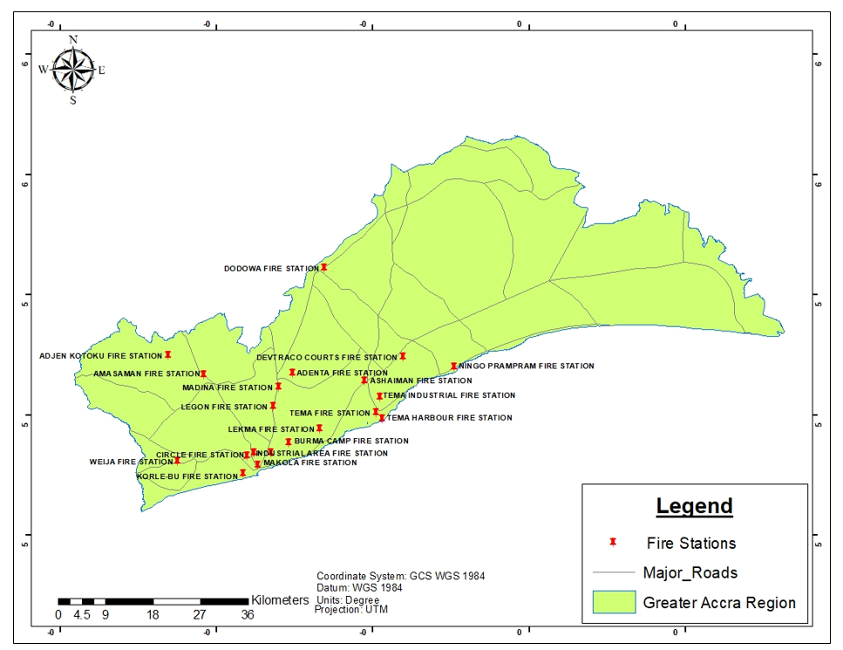**Figure 4.1: Spatial Distribution of Fire Stations in the Greater Accra Region**

### 4.2.2 Service Areas of Existing Fire Stations

The international standards for fire safety and management, also per the fire standard codes, the maximum areal coverage of a fire service station should be 8km (NFPA, 2021). Thus, a fire station should be positioned so that every region of the jurisdiction is within 5 miles (8 kilometers) of a fire station (NFPA, 2021). It is agreed that anything beyond the 8km jurisdiction of a fire station is considered an area with no known fire protection.

Figure 4.2 shows the results of the proximity analysis of an 8km radius buffer around existing fire stations in GAR. The cream regions represent an 8 kilometers coverage service area of present fire service stations.

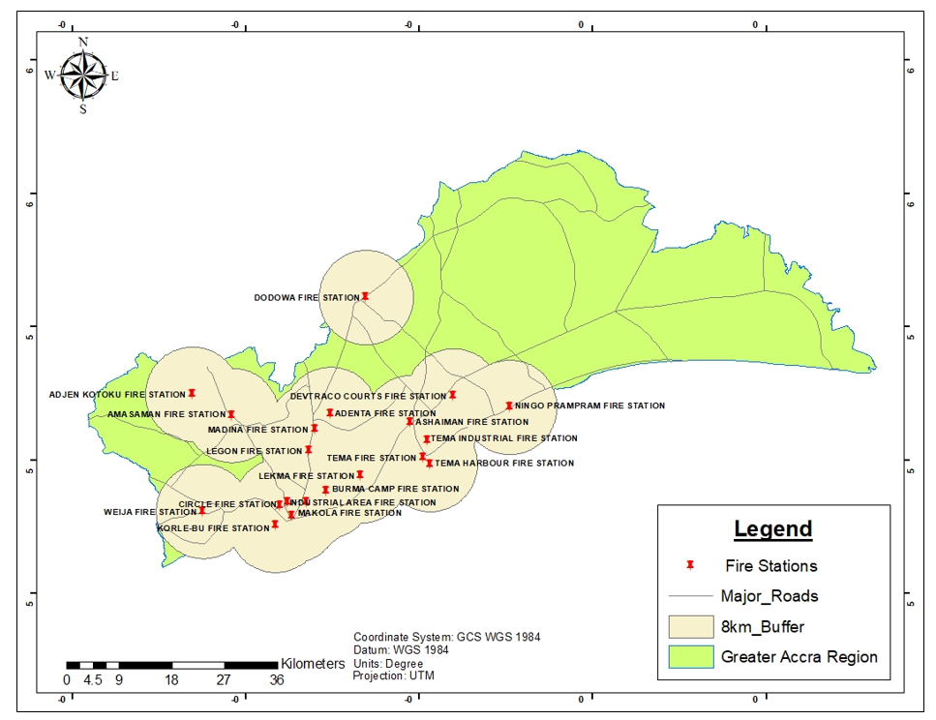

**Figure 4.2: Buffer Analysis of 8km of Existing Fire Stations in Greater Accra**

Data sourced from the Open Street Map in the study area as seen in Figure 4.3 to determine the average travel time in 3 intervals of 5, 10 and 15 minutes which comprised of average traffic conditions and existing road networks were used in the analysis. The network analysis tool in Arc Pro was employed in the acquisition of the optimum time of travel to display the average time of travel of 5 minutes of existing fire stations to determine the area coverage.

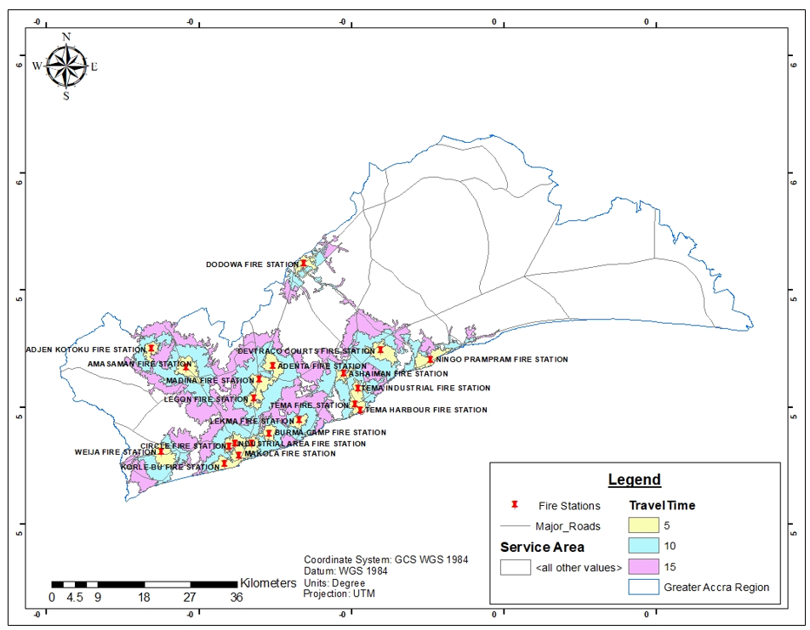

**Figure 4.3: Estimated Service Area Coverage of Existing Fire Stations in Greater Accra within 5 – 15 minutes Travel Time**

Figure 4.3 represents the likely service area of existing fire service stations between 5 to 15- minute travel times to informed fire incident scenes. The distance travelled from the fire station to the disaster scene was set to 5 minutes in relation to NFPA Standard Codes, and the fastest route was used to study the travelling time (NFPA, 2021).

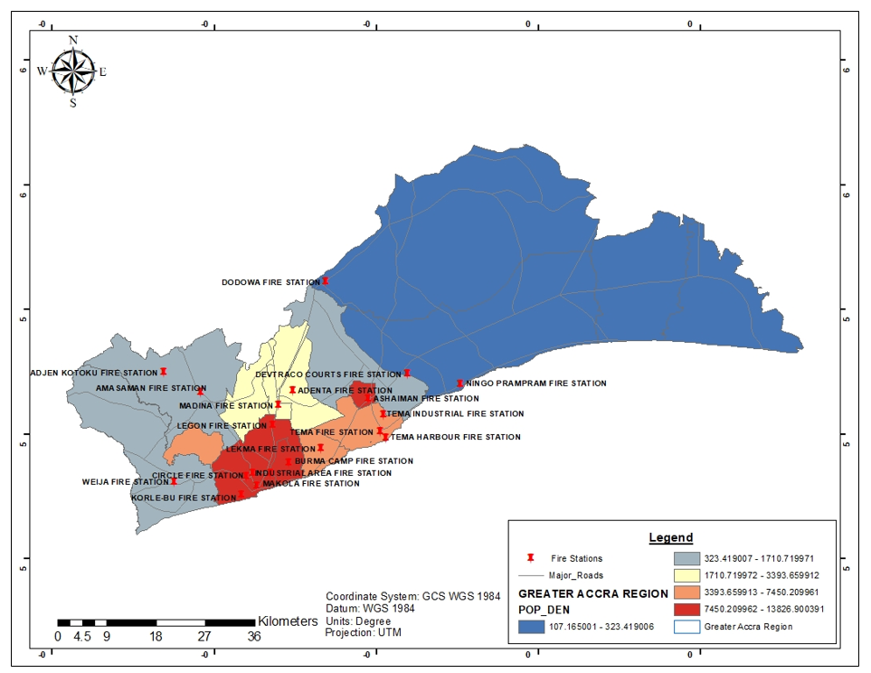

**Figure 4.4: Estimated Population Density in 2021 in Greater Accra**

Population estimates from the United Nations were used to calculate population density for the analysis (WorldPop, 2021) with respect to existing fire stations. Figure 4.4 shows an overlay of current fire stations on a visual distribution of the population density in Greater Accra in 2021. The graded hues in figure 4.4 represent the population density. The red portion on the map depicts high-density regions with over 13, 000 people living within a square kilometer, whereas low-density areas are depicted in shades of blue. Mid-dense regions are depicted in cream and grey on the map.

### 4.2.3 Predicting Areas Suitable for Citing New Fire Stations

A site suitability analysis for new fire stations was created based on the service area coverage of existing fire stations and the population density of the area. It also identified regions susceptible to the occurrence of fire outbreaks as seen in Figure 4.5. Zones that are best for citing fire stations in Greater Accra are shown by the graduated color from red to green in Figure 4.5, from most to least. The best places to cite a fire service station are those shown in green. However, Figure 4.5 also shows that there are some existing fire stations in these localities. The second-most appropriate place to cite a fire station is the area shown in orange. A visual interpretation of Figure 4.5 reveals that the majority of the areas depicted in orange that would be appropriate for a fire station are missing one. In Figure 4.5, pockets of yellow areas also point to the third-most appropriate location for a fire station within the city, while red patches indicate the least appropriate location. Due to the low population density within certain district as compared to other district in the study area, hence represented in white and are considered negligible in the model.

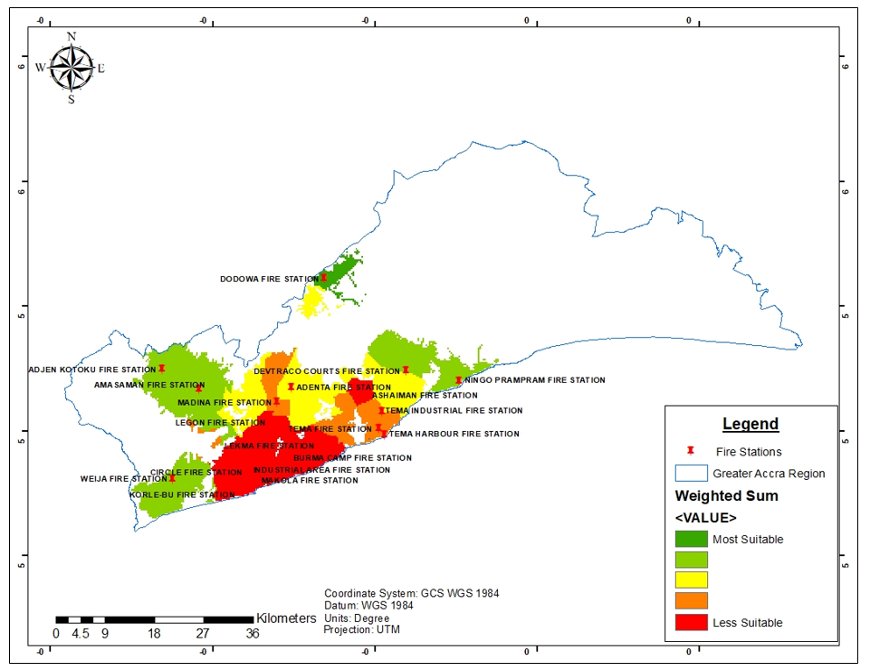

**Figure 4.5: Suitability map for citing new fire stations in Greater Accra Region**

## 4.3 Discussions

Inference from the study demonstrates the geographical arrangement of fire stations within the GAR as shown in Figure 4.1. According to, Abdalla (2016), emergency responders can get a more complete picture of a situation as a result of the various data layers and the visuals GIS provides in the event of an emergency. The finding revealed the uneven distribution of the fire stations within the GAR is a major consideration as it is crucial for rapid response to emergencies.

Yao et al., (2019) also highlighted several factors which include the location of fire stations, water sources and fire hydrants, the road network for the best response, the coverage of the service area, and the response time limitations that hinder the development of effective fire response management. However, identifying the locations of fire hydrants and their condition was a limitation in this study. Inference from the study revealed in Figure 4.2 portions within GAR are not covered by fire stations upon the application of an 8km buffer analysis around existing fire stations according to international standards for accessibility. Ideally, in any built-up urban region within 1.5 miles (2.5 kilometers), there should be a fire protection area assigned to a fire service (NFPA, 2021; Chaudhary et al., 2016).

Findings, from the study, confirm the assertion made in prior studies concerning time as a key criterion in emergency fire response (Forkuo & Ballard, 2013). Network analysis was used to ascertain the service coverage area of existing fire stations within a period of 5-minute, 10-minute and 15-minute. Information on population density help to understand the service regions occupied by existing fire.

In relation to the study, as shown in figure 4.3, the yellow areas relate to cover areas that can be reached in 5 minutes, whereas the cyan areas may be reached in 10 minutes. In Greater Accra, the average distance traveled in a five-minute trip is eight kilometers, while a ten-minute trip covers an average distance of 2.4 kilometers. An average coverage of 4.89 kilometers was the outcome of a 15-minute coverage analysis is shown in purple on the map. Despite, the even distribution of fire stations throughout Ablekuma (North, Central, and South), Ashiedu Keteke, Okaikoi South and Korle Klottey Municipal, the average time of travel with the current road networks is 10-minutes, this finding is attributed to the heavy traffic congestion (Musah et al., 2020).

The study further reveals that the uneven distribution of fire stations in the region is a result of high population density in these areas at the time of funding for new fire station allocation. Therefore, the efficiency of emergency response during fires is greatly influenced by the number and location of fire stations (Lui et al., 2006**).** The distribution of the population is crucial when quoting fire stations because dense building coverage results from a large population in a specific location (Nyimbili et al., 2018). This suggests that homes in densely populated places are often located close together and on tiny lots, which raises the risk of fires and accelerates their spread.

However, the study reveals that the population has increased with respect to time in all the districts of the Greater Accra Region as a result of the effects of urbanization and urban growth. This confirms prior reports on the country’s rising fire risk as a result of rapid urbanization (Addai et al., 2016). In view of that this study highlights the need to cite new fire service stations.

To satisfy the expanding demands of the urban environment, key agencies in disaster management and prevention in the Greater Accra Region must take a keen interest in these, communities such as Gbawe, Mallam, Awoshie, Lapaz, Adriganor, Dawhenya, Sakumono, Kpone Katamanso and Tema New Town, among others. However, prior studies identified the use of location set covering problems and the maximal coverage location problem (Chen et al., 2018) when deciding where to place the fire station. This study agrees the weighing competing criteria such as time, distance and coverage (Yao et al., 2019) in the optimal placement of fire stations. Findings from this study will help the GAR to make decisions using GIS-based suitability models for site selection and facility allocation in the urban planning process.

# CHAPTER FIVE

# CONCLUSIONS AND RECOMMENDATIONS

## 5.1 Introduction

This research has been undertaken to elaborate on certain metrics or parameters that need to be considered when dealing with emergency fire response. Specifically, it examines the examines the sptatial distribution of the fire stations and predict the possible areas for bnew fire stations based on NFSA standards. This chapter discusses the conclusions drawn from the study and makes recommendations for future research and policy directions.

## 5.2 Conclusions

The conclusions drawn in this study have been structured and based on the specific objectives of the study.

**To identify the existing fire response systems in Greater Accra Region (GAR)**

The concept of identifying the existing fire response system in GAR required mapping the geolocation of existing fire stations. ArcMap was used to create a map to visualize the spatial distribution of the existing fire station in the study area for further analysis and decision-making in emergency fire response. However, the availability of fire hydrant is also paramount in combating fire, yet it locations within the study was a limitation.

**To identify the spatial metrics covered by existing fire systems in the study area.**

Also, location, time and population density are the spatial metrics primarily considered by fire stations in GAR. Findings from the spatial analysis of these metrics resulted in identifying the accessibility and service coverage area of the existing fire stations in GAR. Based on the fire regulations standards, (NFPA,2021), 8km is the maximum area coverage a fire station should occupy, this was performed by applying the buffer analysis in ArcMap while ArcPro was used to obtain all the necessary road and traffic data for the network analysis from Open Street Map. These parameters create an avenue for accessing an existing fire station efficiency within a particular area in case of a fire outbreak. This confirmed the difference in response time by the fire station. Therefore, this finding revealed areas that are covered by fire stations and areas that do not have any fire service station coverage.

**To predict suitable sites for new fire systems for efficiency.**

The population density was also mapped out from the population data of the study area to identify areas with or without any existing fire stations. As additional criterion, the findings in the study pointed out the need to develop site suitability map to identify potential locations for future fire service stations in Greater Accra Region. Using the weighted overlay tool in ArcMap, each criterion was given an equal amount of weight to produce the suitability map.

In summary, the application of geospatial tools as an effective resource to optimize the geographic locations of fire stations will go a long way to minimize the challenges faced by stakeholders in combating fire disasters within GAR.

## 5.3 Recommendations

Upon the conclusion and limitation of this work. I recommend that further research should be conducted by including the mapping of locations of fire hydrant in the study area to help stakeholders to make precise decisions in responding to fire outbreaks.

# REFERENCES

Abdalla, R. (2016). Evaluation of spatial analysis application for urban emergency management. SpringerPlus, 5(1), 1-10.

Addai, E. K., Tulashie, S. K., Annan, J. S., & Yeboah, I. (2016). Trend of fire outbreaks in Ghana and ways to prevent these incidents. Safety and health at work, 7(4), 284-292.

Al-Khudhairy, D. H. (2010). Geo-spatial information and technologies in support of EU crisis management. International Journal of Digital Earth, 3(1), 16-30.

Anaglatey, P.B. (2013). Accra continues to record ﬁre outbreaks. The Chronicle.

Anni, P. K. (2018). A Study of Sekondi-Takoradi residents’ perception of firefighting operations by Ghana National Fire Service (Doctoral dissertation).

Badri, M. A., Mortagy, A. K., & Alsayed, C. A. (1998). A multi-objective model for locating fire stations. European Journal of Operational Research, 110(2), 243-260.

Barnett, A. P., & Okoruwa, A. A. (1993). Application of geographic information systems in site selection and location analysis. The Appraisal Journal, 61(2), 245.

Boeing, G. (2017). OSMnx: New methods for acquiring, constructing, analyzing, and visualizing complex street networks. Computers, Environment and Urban Systems, 65, 126-139.

Bruslinskiy, N. N., Sokolov, S. V., & Ivanova, O. V. (2019). How many fire deaths are in the world?. Pozharovzryvobezopasnost/Fire and Explosion Safety, 28(4), 51-62.

Challands, N. (2010). The relationships between fire service response time and fire outcomes. Fire technology, 46(3), 665-676.

Chaudhary, P., Chhetri, S. K., Joshi, K. M., Shrestha, B. M., & Kayastha, P. (2016). Application of an Analytic Hierarchy Process (AHP) in the GIS interface for suitable fire site selection: A case study from Kathmandu Metropolitan City, Nepal. Socio-Economic Planning Sciences, 53, 60-71.

Chen, Z. F., Li, J. W., Lu, F. X., & Li, Q. (2018). Optimizing location of fire stations and it’s enlightenments for Xiongan New Area. Journal of Safety Science and Technology, 14, 14-19.

Chevalier, P., Thomas, I., Geraets, D., Goetghebeur, E., Jansens, O., Peters, D., & Plastria, F. (2012). Locating fire stations: An integrated approach for Belgium. Socio-Economic Planning Sciences, 46(2), 173-182.

Church, R. L., & Murray, A. (2018). Location covering models. Advances in Spatial Science.

Cutter, S. L. (2003). GI science, disasters, and emergency management. Transactions in GIS, 7(4), 439-446.

Department of Economic and Social Affairs Population Dynamics. (2019). World Population Prospects - Population Division - United Nations. United Nations. https://population.un.org/wpp/

Donner, W., & Rodríguez, H. (2008). Population composition, migration and inequality: The influence of demographic changes on disaster risk and vulnerability. Social forces, 87(2), 1089-1114.

Dooley, C. A., Leasure, D. R., & Tatem, A. J. (2020). Gridded maps of building patterns throughout sub-Saharan Africa, version 1.1. University of Southampton: Southampton, UK.

Drobne, S., & Lisec, A. (2009). Multi-attribute decision analysis in GIS: weighted linear combination and ordered weighted averaging. Informatica, 33(4).

Drysdale, D. (2011). An introduction to fire dynamics. John wiley & sons.

Ecopia Tech Corporation. (2020). Ecopia AI - Digitizing the World using AI. https://www.ecopiatech.com/

Erden, T. (2012). Disaster and emergency management activities by geospatial tools with special reference to Turkey. *DISASTER ADVANCES*, *5*(1), 29-36.

Erden, T., & Coşkun, M. Z. (2010). Multi-criteria site selection for fire services: the interaction with analytic hierarchy process and geographic information systems. Natural Hazards and Earth System Sciences, 10(10), 2127-2134.

ESRI. (2006). GIS Technology and Applications for the Fire Service. An ESRI White Paper. Retrieved from https://www.esri.com/library/whitepapers/pdfs/fire-service-gis-applications.pdf

ESRI. (2021). Types of network analysis layers—ArcMap | Documentation. Accessed from: https://desktop.arcgis.com/en/arcmap/latest/extensions/network-analyst/types-of-network-analyses.htm#GUID-DA84EF13-E616-47AE-A0EE-0CB797056066

Evans, J. R., & Minieka, E. (2017). Optimization Algorithms for Networks and Graphs: Revised and Expanded. CRC Press.

Fleming, R. S. (2010). Effective fire and emergency services administration. Fire Engineering Books.

Fischer, R. J., Halibozek, E. P., & Walters, D. C. (2019). Contingency planning emergency response and safety. Introduction to security, 249.

Forkuo, E. K., & Quaye-Ballard, J. A. (2013). GIS based fire emergency response system.

Fuhrmann, S., MacEachren, A., & Cai, G. (2008). Geoinformation technologies to support collaborative emergency management. In Digital Government (pp. 395-420). Springer, Boston, MA.

Gakpe, B. K., & Mahama, P. Y. (2014). Reportage of stories on fire outbreaks in Ghana: an analysis of the Daily Graphic and the Chronicle. Reportage, 24.

Gbanie, S. P., Tengbe, P. B., Momoh, J. S., Medo, J., & Kabba, V. T. S. (2013). Modelling landfill location using geographic information systems (GIS) and multi-criteria decision analysis (MCDA): case study Bo, Southern Sierra Leone. Applied Geography, 36, 3-12.

Geng, S., Hou, H., & Zhang, S. (2020). Multi-criteria location model of emergency shelters in humanitarian logistics. Sustainability, 12(5), 1759.

Hecht, R., Herold, H., Behnisch, M., & Jehling, M. (2019). Mapping Long-Term Dynamics of Population and Dwellings Based on a Multi-Temporal Analysis of Urban Morphologies. ISPRS International Journal of Geo-Information, 8(1), 2.

Huang, I. B., Keisler, J., & Linkov, I. (2011). Multi-criteria decision analysis in environmental sciences: Ten years of applications and trends. Science of the total environment, 409(19), 3578-3594.

Jankowski, P. (1995). Integrating geographical information systems and multiple criteria decision-making methods. International journal of geographical information systems, 9(3), 251-273.

Kahanji, C., Walls, R. S., & Cicione, A. (2019). Fire spread analysis for the 2017 Imizamo Yethu informal settlement conflagration in South Africa. International journal of disaster risk reduction, 39, 101146.

Keenan, P. B., & Jankowski, P. (2019). Spatial decision support systems: Three decades on. Decision Support Systems, 116, 64-76.

Kiran, K. C., Corcoran, J., & Chhetri, P. (2020). Measuring the spatial accessibility to fire stations using enhanced floating catchment method. Socio-Economic Planning Sciences, 69, 100673.

Korah, P. I. (2021). Smart urban development strategies in Africa? An analysis of multiple rationalities for Accra’s City Extension Project. In Smart Cities for Technological and Social Innovation (pp. 157-180). Academic Press.

Liu, N., Huang, B., & Chandramouli, M. (2006). Optimal siting of fire stations using GIS and ANT algorithm. Journal of computing in civil engineering, 20(5), 361-369.

Mansourian, A., Rajabifard, A., & Zoej, M. J. V. (2005). Development of a web-based GIS using SDI for disaster management. In Geo-information for disaster management (pp. 599-608). Springer, Berlin, Heidelberg.

Mara, S. T. W., Kuo, R. J., & Asih, A. M. S. (2021). Location‐routing problem: a classification of recent research. International Transactions in Operational Research.

Marsh, M. T., & Schilling, D. A. (1994). Equity measurement in facility location analysis: A review and framework. European journal of operational research, 74(1), 1-17.

McEntire, D. A. (2015). Disaster response and recovery: strategies and tactics for resilience. John Wiley & Sons.

Moe, T. L., & Pathranarakul, P. (2006). An integrated approach to natural disaster management: public project management and its critical success factors. Disaster Prevention and Management: An International Journal.

Murray, A. T. (2013). Optimising the spatial location of urban fire stations. Fire Safety Journal, 62, 64-71.

Murray, A. T. (2015). Fire station siting. In Applications of location analysis (pp. 293-306). Springer, Cham.

Musah, B. I., Peng, L., & Xu, Y. (2020). Urban Congestion and Pollution: A Quest for Cogent Solutions for Accra City. In IOP Conference Series: Earth and Environmental Science (Vol. 435, No. 1, p. 012026). IOP Publishing.

National Fire Protection Association (NFPA). (2021). Codes and standards | NFPA. Accessed from: https://www.nfpa.org/Codes-and-Standards

Norman, I. D., Awiah, B. M., Aikins, M. K., & Binka, F. N. (2015). Review of catastrophic fires and risk communication, Ghana. Advances in Applied Sociology, 5(05), 167.

Nousiainen, K. (2021). A new Urban Metabolism approach: Combining satellite data and urban metabolism assessment for promoting sustainable urban development.

Nyimbili, P. H., & Erden, T. (2018). Spatial decision support systems (SDSS) and software applications for earthquake disaster management with special reference to Turkey. *Natural Hazards*, *90*(3), 1485-1507.

Occupational Safety and Health Administration (OSHA) (2015). Fire Service Features of Buildings and Fire Protection Systems. Occupational Safety and Health Administration, U.S. Department of Labor. https://www.osha.gov/sites/default/files/publications/OSHA3256.pdf

Okyere, S. E. (2010). Infernos in our offices; demystifying the facts. The Chronicle, 3.

Osaragi, T., & Oki, T. (2017). Wide-area evacuation simulation incorporating rescue and firefighting by local residents. Journal of Disaster Research, 12(2), 296-310.

Plane, D. R., & Hendrick, T. E. (1977). Mathematical programming and the location of fire companies for the Denver fire department. Operations Research, 25(4), 563-578.

Rodriguez, S. A., Rodrigo, A., & Aguayo, M. M. (2020). A facility location and equipment emplacement technique model with expected coverage for the location of fire stations in the Concepción province, Chile. Computers & Industrial Engineering, 147, 106522.

Safo, J. A. (2021, January 8). Fire outbreaks on the rise - Fire Service concerned. Graphic Online. https://www.graphic.com.gh/news/general-news/fire-outbreaks-on-the-rise-fire-service-concerned.html

Şen, A., Önden, İ., Gökgöz, T., & Şen, C. (2011). A GIS approach to fire station location selection. GeoInformation for disaster management.

Shekhar, S., & Xiong, H. (2008). Esri. *Encyclopedia of GIS*, 290–290. doi: 10.1007/978-0-387-35973-1_369

Simpson, D.E. (2010). Fire protection and safety. A presentation of Ghana National Fire Service (GNFS). Ashanti Regional ofﬁce at a Symposium of Building Technology Students Society (BTSS) Week celebration, Kwame Nkrumah University of Science and Technology (KNUST), Kumasi.

Siobhan, R., & Ellis, N. (2019). Multi-Criteria Decision Analysis and GIS. ArcGIS StoryMaps. Accessed from: https://storymaps.arcgis.com/stories/b60b7399f6944bca86d1be6616c178cf

Swanson, K. (2020, June 4). Evaluating Fire Station Locations. Emergency Reporting. Accessed from: https://emergencyreporting.com/blog/evaluating-fire-station-locations/

Tulashie, S. K., Addai, E. K., & Annan, J. S. (2016). Exposure assessment, a preventive process in managing workplace safety and health, challenges in Ghana. Safety science, 84, 210-215.

Walls, R. S., Eksteen, R., Kahanji, C., & Cicione, A. (2019). Appraisal of fire safety interventions and strategies for informal settlements in South Africa. Disaster Prevention and Management: An International Journal.

Wang, W., Xu, Z., Sun, D., & Lan, T. (2021). Spatial Optimization of Mega-City Fire Stations Based on Multi-Source Geospatial Data: A Case Study in Beijing. ISPRS International Journal of Geo-Information, 10(5), 282.

Waugh Jr, W. L., & Tierney, K. (2007). Future Directions in Local Emergency Management. Emergency Management: Principles and Practice for Local Government, 317-333.

Wilmoth, J. M. (2019). Understanding Mass Fatality Preparedness in the Fire Service through Knowledge Management. Northcentral University.

Worldpop. (2020). WorldPop:: Population Counts. https://www.worldpop.org/geodata/summary?id=49691

World Urbanization Prospects. (2021). Accra Population 2021 (Demographics, Maps, Graphs). Accessed from: https://worldpopulationreview.com/world-cities/accra-population

Wu, Y., Ma, M., Chen, L., & Zhong, Z. (2019, July). IBA-Buffer: Interactive Buffer Analysis Method for Big Geospatial Data. In International Conference on Data Mining and Big Data (pp. 61-69). Springer, Singapore.

Yang, L., Jones, B. F., & Yang, S. H. (2007). A fuzzy multi-objective programming for optimization of fire station locations through genetic algorithms. European Journal of Operational Research, 181(2), 903-915.

Yang, Z., Xie, H., Xu, Y., Xu, Q., Zhang, Y., Zhao, S., ... & Fang, Y. (2020, October). Evaluation of Smart Response Systems for City Emergencies and Novel UV-Oriented Solution for Integration, Resilience, Inclusiveness and Sustainability. In 2020 5th International Conference on Universal Village (UV) (pp. 1-51). IEEE.

Yao, J., Zhang, X., & Murray, A. T. (2019). Location optimization of urban fire stations: Access and service coverage. Computers, Environment and Urban Systems, 73, 184-190.

Zerger, A., & Smith, D. I. (2003). Impediments to using GIS for real-time disaster decision support. Computers, environment and urban systems, 27(2), 123-141.